**Outputs**

Windows command line operations, from standard keyboard input.

**Input screen: -**

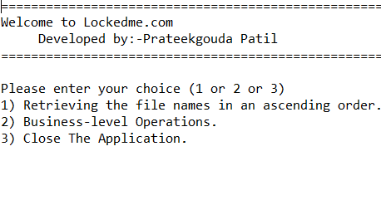

**Output screen 1: - 1 Display all Files (In Ascending Order).**

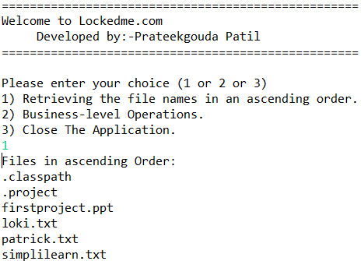

**Output screen 2: -(**Add a new file in given project Files Path)

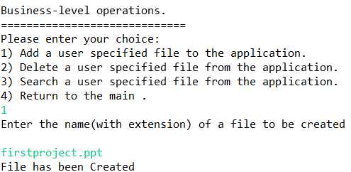

**Output screen 3: -(**Delete a file**)**

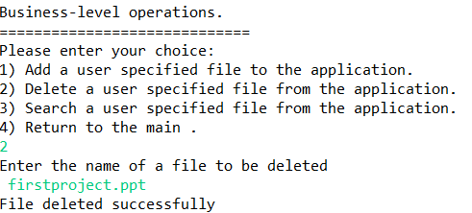

**Output screen 4: -(**Search a file.**)**

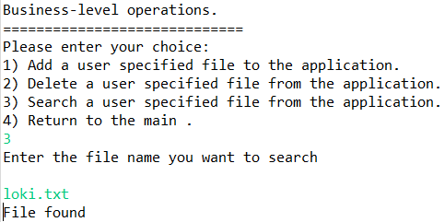

**Output screen 5: -(**File not found.**)**

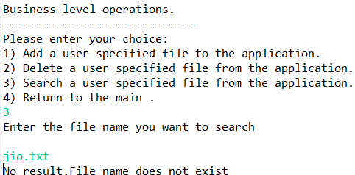

**Output screen 6: - (**Exit from current context.**)**

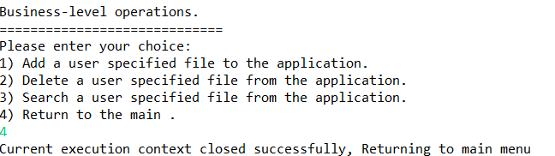

**Output screen 7: -(**Exit from application.**)**

